Pin Inspect Value During Debugging
While debugging in Visual Studio, we generally used mouse over on the object or variable to inspect the current value. This shows the current data items held by the inspected object. But this is for a limited time, as long as the mouse is pointed to that object those value will be available. But in Visual Studio 2010 Beta 2, there is a great feature to pin and unpin this inspected value. We can pin as many of any object and their sub object value also. Please have a look into the below picture:
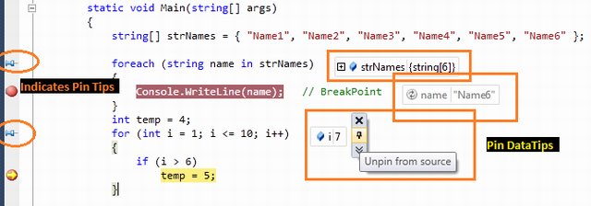
Figure: Pin Inspect Value During Debugging
When you mouse over on the inspect object, you will get pin icon with each and every object's properties, variable. Click on that pin icon to make it pinned. Unless you manually close these pinned items, they will be visible in the IDE.

Consider following code:
#include<iostream>
using namespace std;
int main()
{
int i=0;
int cnt=0;
int a=10;

while(i<10)
{
i++;
cout<<i<<endl;
}
return 0;
}

Place the breakpoint at “i++”
Press F5- start debugging
Now place the mouse over “i++” statement, it will show u a data tip but it is temporary i.e. as long as ur mouse is over that statement.
If you want to pin the variable “I”,
Go to “i++” statement, select “I” ,
Right click and select “Pin to Source”
When a small “pin” window appears , drag it to the left of that variable. Now when u press F5, u will notice the value of that variable inside “pin” window.

Drag-Drop Pin Data Tip
You can easily Drag and Drop the data tip inside the Visual Studio IDE. This is quite helpful when you need to see some object value list in the bottom section of code. You can easily drag those pinned data tips over there.
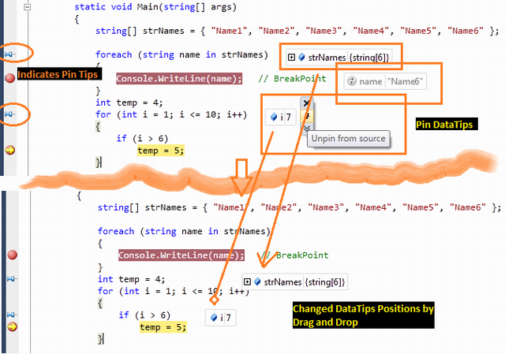
Figure: Drag Drop Data Tips

Adding Comments
You can add comments on the pinned data tip. For providing comments, you need to click on “Expand to see the comments” button. This will brings up an additional textbox to add comments.
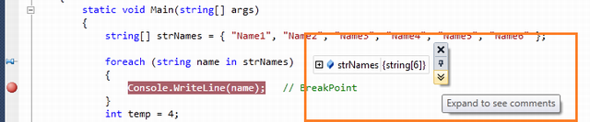
Figure: Comments in DataTip
Below is some demonstration of Adding comments on pinned inspect value:
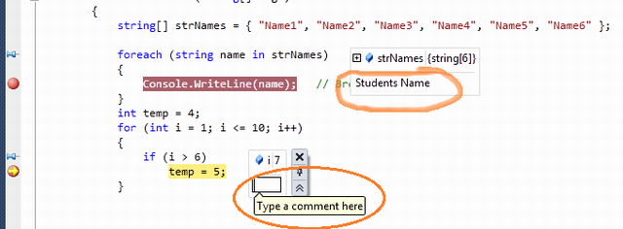
Figure: Adding Comments For Datatips

Last Session Debugging Value
This is another great feature of Visual Studio 2010 debugging. If you pinned some data tip during the debugging, the value of pinned item will remain stored in a session. In normal mode of coding, if you mouse over the pin icon, it will show the details of the last debugging session value as shown in the the below picture:
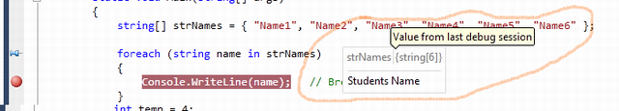
Figure: Last Session Debug Value

